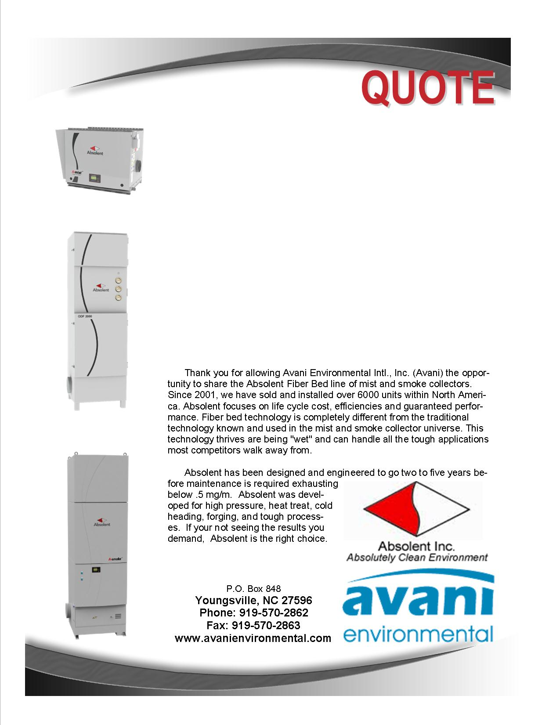

Attn: Jim Owens

**Tool North, Inc.**

**Contract Purchase Order 027788**

Additions Revised for Paint and Duct

Quote by: **Fred Johnson**

Email: fjohnson@avanienvironmental.com

June 25, 2012

**Avani Environmental Intl., Inc.**

**P.O. Box 848**

**Youngsville, NC 27596**

Phone: 919-570-2862 Fax: 919-570-2863

**Quote #: AE-003830 Contract PO 027788 Revised for paint and ducting** June 25, 2012

Quote by: **Fred Johnson**

Attn: Jim Owens

**Tool North, Inc.**

**2475 North Aero Park Court**

**Traverse City, MI 49686**

Dear Jim,

Since we have agreed upon a Contract, there are several requests to modify the Absolent unit, I have outlined these changes for your final consideration. As discussed, the unit is being manufactured in Sweden and we can employ these changes as part of the contract. The delivery date estimate to Tool North in Traverse City Michigan is August 15, 2012.We have revised the leg height addition to $1,100.00. We have added the Jacob Tubing and 16” inlet plenum.

|  |  |  |  |  |  |
| --- | --- | --- | --- | --- | --- |
| **Product Name** | **Product Description** | **Product Picture** | **Quantity** | **Unit Price** | **Total Price** |
| AB-ODF-8000TF  Support Legs  Paint RAL 7047 | ODF 8000TF, mist collector, 10 hp (direct drive), vertical configuration and magnehelic gauge.  Dimensions: 50" x 56" x 107"  Inlet: 15.8"  Weight (with filters): 1675 lbs  Noise Level: 75 dba  Electrical: 254/280 v, 3-phase  Filtration: Filter Bed 1: 616 sq ft  Filter Bed 2: 552 sq ft  Absolute Filter: 876 sq ft  Unit legs to be 907 mm or 35.74” per attached 3D drawing  Absolent to set up and paint unit and legs RAL 7047 |  | 1  1 Set  1 | $22,255.00  Net $1,520.00  Net  $587.00 | $22,255.00  Note: This price is discounted  15%  $1,100.00 This price is discounted 15%  $587.00 This price is discounted 15%  Total Price for Absolent Unit is $23,942.00. |
| Jacobs Duct  NOTE: Customer drawing provided 4/15/12 for final Duct Package price  Paint RAL 7047 | Jacobs Duct: The estimated routing is a location within 23.5’ of the machining center using 16” diameter duct. The mist collector uncludes an inlet box to eliminate an elbow. The mist collector is floor mounted. Mounting to the machine will be at the top in one 14” fitting. We will use two 90 degree elbows.  Provide Jacob duct and AEI 16” inlet box painted |  | 1  16” Pipe  16” Inlet Box | $2,495.00  $230.00 | $2,495.00  $320.00  $230.00  $3,045.00  15% Discount applied |
|  |  |  |  |  |  |
|  |  |  |  | **Grand Total:** | **$26,987.00** |

**Total does not include shipping cost**

Additional Product Options:

|  |  |  |  |  |
| --- | --- | --- | --- | --- |
| **Name** | **Product Description** | **Quantity** | **Unit Price** | |
| Drain Pipe | 1” “P” Trap with fittings and valve, PVC construction |  | Net $80.00 | |
|  |  |  |  | |
|  |  |  |  |

Let me know if you have any questions and when it would be convenient for you and your staff to begin discussing final terms of a contract.

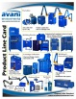 Feel Free to Review the Avani Product Line: [CLICK HERE](http://issuu.com/avanienvironmental/docs/product_line_card_new_2011?mode=window&backgroundColor=%23222222).

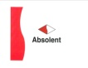 Feel Free to Learn about the Absolent Product Line: [CLICK HERE](http://miststop.com/)

Sincerely,

**Fred Johnson,**

Phone: 847-902-2210 Cell

Email: fjohnson@avanienvironmental.com

**Terms and Conditions**

*General:*

1. The price does not include sales tax, duties, custom fees or any other cost associated with the sale or delivery of this product.
2. Payment terms: 10% with order, 90% net 30 days.
3. New customers or dealers must pay 35% down with Purchase Order(s).
4. Quotation price does not include actual shipping costs. If requested by Buyer, Avani can supply an estimated shipping cost(s).
5. There is a 20% restocking / cancellation fee for all Purchase Orders.
6. Not responsible for shipping and handling costs for Warranty issues/items.
7. Warranty only includes replacement parts not labor or any other cost associated with replacing warranty Items.
8. All Products are FOB: Manufacturer

*Installations:*

1. Price of installation does not include the following costs. Avani can quote these cost if need be but prices will be based upon a local contractor.
   1. Electrical wiring, running wires, or anything associated with electrical work
   2. Lifting equipment or any other heavy equipment required to install the equipment
   3. Demolition work and cutting holes through concrete or metal.

*Demo Units:*

1. Available for up to 30 days.
2. Must pay for shipping to your facility and back to Avani’s warehouse; if returning the product(s).
3. If there is filter media in the product all filter media must be paid for if the product(s) is returned.
4. If product is returned; the product must return in the same condition as when shipped from Avani’s warehouse, if scratched or damaged additional charges will be applied.
5. To obtain a Demo unit. First, talk with an Avani representative for approval and availability. Second, send in a Purchase Order, just like you would be purchasing the unit, and put DEMO UNIT on the Purchase Order.
6. After the Demo trial period is over payment is due upon receipt of Invoice.

*Shipping and Delivery Time:*

1. Stock items will ship within 1 week; Non-Stock items will ship within 8-10 weeks. Custom Products could ship in 12-16 weeks. These times are estimates only and may be revised at anytime.
2. All standard stock products will be shipped from Avani’s warehouse: Youngsville, NC 27596
3. Unless otherwise stated we ship items in the best way.
4. The delivery of the products will be ex-works: if requested by the Buyer, Avani will arrange delivery and insurance of the Products in transit at the Buyer’s expense.
5. The Buyer is responsible for inspecting the Products immediately when they are delivered and must state upon delivery if the Product is damaged or has missing parts, if not the Products are acknowledged as being satisfactory quality and are not missing any parts.