
山貿科技有限公司 SAN MAO TECHNOLOGY CO., LTD
台中市神岡區大明路191巷92號 No. 92, Lane 191, Daming Rd., Shengang District, Taichung City, Taiwan
Tel: +886-4-2526-9689 Fax: +886-4-2526-9860
E-mail: sales@smartvent-technology.com Website: http://www.smartvent-technology.com

April 22, 2011

ORDER CONFIRMATION
INVOICE NO. P-1000409-001 (Revised I)
PO NO. 3068
INVOICE of Welding Booth
For account and risk of Messrs. AVANI ENVIRONMENTAL INTL. INC.
95 Cypress Drive, Youngsville, NC 27596
Shipped by: SAN MAO TECHNOLOGY CO., LTD.
From: Taiwan to USA

Welding Booth
FOB TAIWAN
Amtrak Seattle
Item | Model | Description | Unit  Price |  | Q’ty |  | Total
1 | Amtrak - 1000  WB-18x10x8P | Welding Booth:  - Welding booth dimension:18ft. x 10 ft. x 8 ft.  - Construction: 12 gauge welded steel panel skins on a 2² square stock frame with adjustable feet and powder coated.  - Booth must include opaque front doors.  - (2) swing out doors – total dimension: 10’L x 8’H.  - (2) viewing window preserved – each dimension: 20”L x 24”H. Avani to provide speedy glass.  - Total (2) backdraft modules for WB-18x10x8P:  - (1) backdraft is composed by (2) back walls.  - Backdraft module for each booth. Attachments on each side of slotted backdraft:  - Provide (4) adjustable slots for extraction: (1) adjustable slot near (1) recessed working light; (3) adjustable slots for backdraft  - (2) 110V electrical (2-plugs)  - (1) 110V switch for working light  - (1) quick connector for CO2  - (1) quick connector for air compressor connection  - (1) recessed working light  - (1) arm port: 8”  - (1) CO2 welding bracket shared for WB-18x10x8P  - Paint color: Oskar blue.  - Logo: Oskar  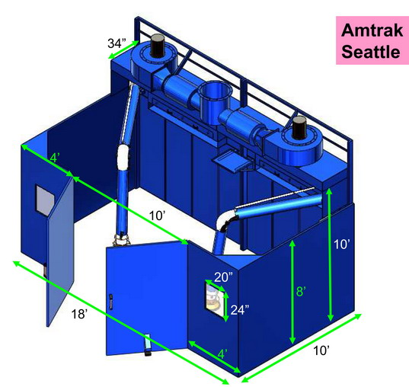  no fans,  no silencers, no plenum  **Reference: Amtrak Seattle - WB-18x10 + 8inch x 14' arm 2011.04.19 |  | US 13200 |  | 1 | US 13200
2 | ARM 2040 | Hanging Fume Arm with Oversize Hood  Spec: Dia. 8” x 14’  Including: Hose Connector  Arm Color: Oskar Blue |  | US 479 |  | 2 | US 958
TOTAL AMOUNT: US$ 14,158.00
Remark:
- PAYMENT: 35% down payment remitted before shipment; another 35% wire transferred when the container is approaching to US; 30% balance cleared one month after ETA date of the container.
- SHIPMENT: 45 days after confirmation of O.C. With any available container closer to the delivery time.
- VALIDITY: 6 months.
- PACKING: Our standard packing

Bank:
MEGA INTERNATIONAL COMMERCIAL BANK CO., LTD FENG YUAN BRANCH
519 CHUNG CHENG ROAD FENG YUAN, TAIWAN, R.O.C
TEL: 886-4-25285566 FAX: 886-4-25206431

SWIFT ADDRESS: ICBCTWTP 035
Account NAME: SAN MAO TECHNOLOGY CO., LTD
Account NO. 035-585-46208

SAN MAO TECHNOLOGY CO., LTD AVANI ENVIRONMENTAL INTL. INC.
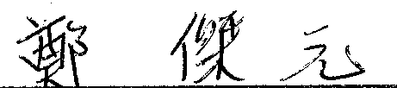
CHARLES CHENG CHARLES SITHES
General Manager Product Manager

